Acceptance Testing
UAT Execution & Report Submission
Project Name | Emotion Detection and Learning Support Engine
Team ID | SWTID-2026-2247
Date | 07 July 2026
Maximum Marks | 4 Marks

1. Purpose of Document
The purpose of this document is to explain the test coverage and open issues of the Emotion Detection and Learning Support Engine project at the time of release to User Acceptance Testing (UAT). It summarises the defects identified during the testing cycle, how each was resolved, and the overall pass rate of test cases across every functional module, giving stakeholders a clear picture of the product's readiness for real-world use by learners and instructors.

2. Scope of User Acceptance Testing
UAT for this release covered the complete learner-facing workflow, from the moment a learner's video, audio, and interaction data is captured, through emotion classification, to the delivery of adaptive learning content and the instructor-facing analytics dashboard. The scope also included the underlying security and privacy controls that protect learner data, the exception handling behaviour of the platform when sensors fail or connections drop, and the version control mechanism used to track updates to the emotion detection model.

3. Defect Analysis
During the testing cycle, a total of 77 defects were logged across four severity levels. Severity 1 defects represent critical issues that block core functionality, while Severity 4 defects represent minor or cosmetic issues. Each defect was triaged and resolved through one of several outcomes: fixed in the codebase, accepted as intended behaviour (by design), identified as a duplicate of an existing report, attributed to an external dependency, found not reproducible, deliberately skipped for this release, or declined as won't fix.
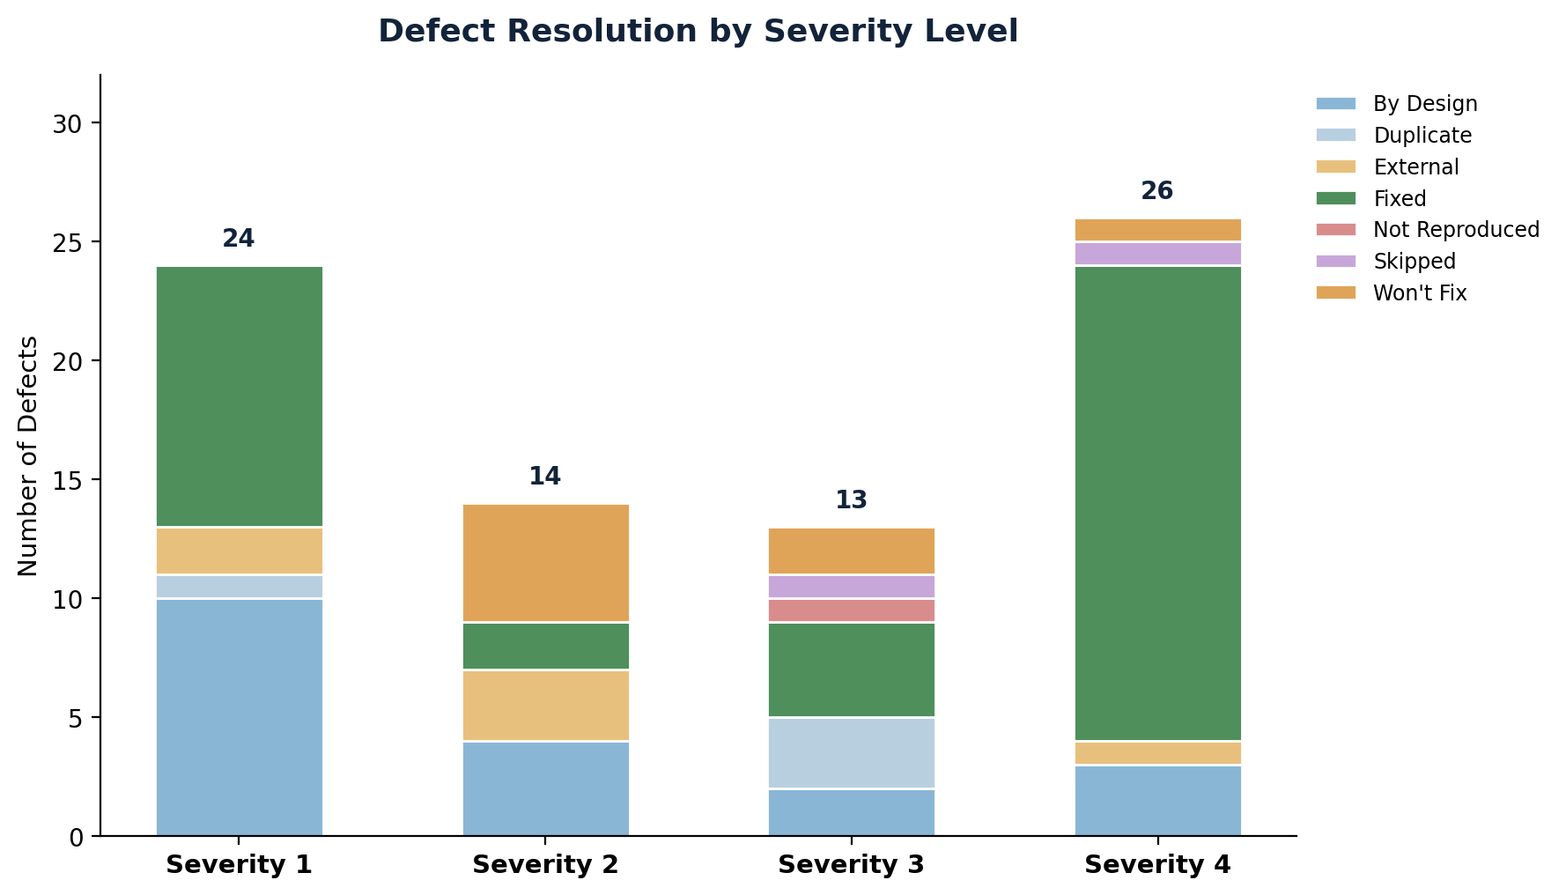
Figure 1: Defect resolution outcomes broken down by severity level
The majority of defects were resolved through direct fixes, accounting for 37 of the 77 logged issues, with the largest concentration of fixes in the lower-severity Severity 3 and Severity 4 categories. Only a small number of Severity 1 and Severity 2 defects remained as by-design decisions or duplicates, and none of the unresolved items were assessed as blocking for release. This distribution indicates that the majority of user-impacting issues were addressed before UAT sign-off, while a smaller set of low-priority items were consciously deferred.

4. Test Case Analysis
Test case execution was tracked across every functional module of the platform. The Learning Support Engine, being the most feature-rich module responsible for adaptive content selection, carried the largest share of test cases, while smaller modules such as security and version control were covered with a proportionate but complete set of cases.
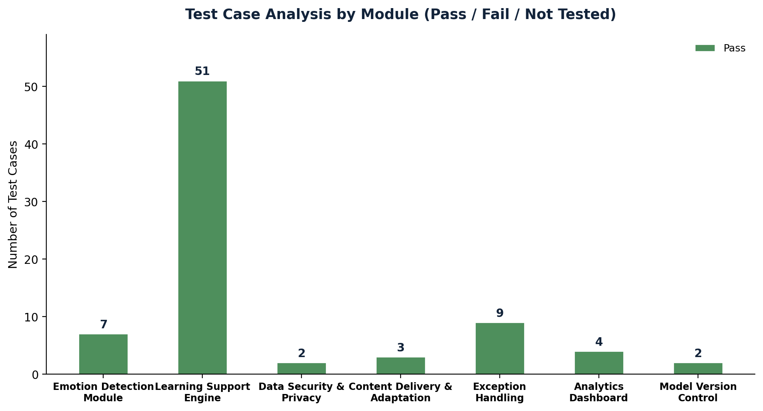
Figure 2: Test case pass rate across functional modules
A total of 78 test cases were executed across the Emotion Detection Module, Learning Support Engine, Data Security and Privacy controls, Content Delivery and Adaptation logic, Exception Handling, Analytics Dashboard reporting, and Model Version Control. Every test case across all seven modules passed, with zero cases marked as failed or left untested, giving strong confidence that the platform is functionally complete and stable heading into UAT.

5. Key Observations
- The Learning Support Engine module carried the highest test volume and passed all cases, confirming the reliability of the adaptive content logic.
- The concentration of Severity 1 fixes in the Emotion Detection Module suggests this area required the most iteration, which is expected for a machine-learning-driven component.
- No Severity 1 defects remain open, which removes any blocking risk ahead of UAT sign-off.
- A small number of Severity 3 and Severity 4 items were skipped or marked won't fix, and should be revisited in a future release cycle.

6. Conclusion and Recommendation
Based on the defect resolution outcomes and the complete pass rate across all test case categories, the Emotion Detection and Learning Support Engine is assessed as ready for User Acceptance Testing. No open Severity 1 issues remain, and all functional modules have demonstrated stable behaviour during test execution. It is recommended that UAT proceed on schedule, with the small set of deferred low-severity items tracked for resolution in a subsequent release.

